VISVESVARAYA TECHNOLOGICAL UNIVERSITY
Computer Graphics Laboratory with Mini Project

Basic Solar System 2D
A 2D OpenGL Mini Project in C

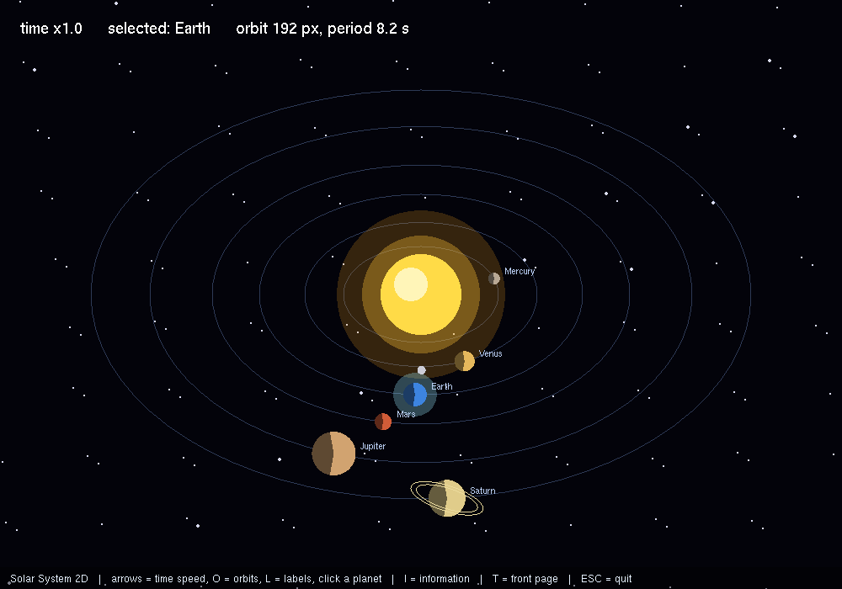

Mini-Project Report
Department of Computer Science and Engineering
Copyright (c) 2026 Suman Hugar. All rights reserved.

Table of Contents
1. Introduction
2. Objectives
3. System Requirements
4. Design and Architecture
5. OpenGL Concepts Demonstrated
6. Geometry and Primitives
7. User Interface and Controls
8. Building and Running
9. Results
10. Viva Questions and Answers
11. Limitations and Future Work
12. Conclusion

1. Introduction
Basic Solar System 2D is a 2D computer graphics mini project written in C using the OpenGL fixed-function pipeline and the GLUT windowing toolkit. The program is 639 lines of source in a single translation unit and depends on nothing beyond OpenGL, GLU and freeglut — there are no model files, image files or other external assets to lose.
Everything drawn on screen is produced in code from OpenGL primitives. That constraint is the point of the exercise: it forces every shape, every movement and every shading decision to be expressed explicitly, which is what makes the project examinable.
The techniques the program demonstrates are:
- Alpha blending
- Matrix stack (hierarchical modelling)
- Orthographic projection
- Timer-driven animation
- Mouse input
- Mouse motion tracking
- Keyboard input
- Special (arrow) keys
- Text rendering

2. Objectives
- To design and implement a complete 2D scene using the OpenGL fixed-function pipeline and GLUT.
- To apply the geometric transformations of the syllabus — translation, rotation and scaling — through the modelview matrix.
- To demonstrate hierarchical modelling using the matrix stack, so that composite objects move as a unit.
- To produce smooth, flicker-free animation using double buffering and a timed update loop.
- To accept and respond to user input at run time through GLUT event callbacks.
- To use alpha blending for transparency and soft-edged effects.
- To produce a program that builds and runs unchanged on both Linux and Windows.

3. System Requirements
Software
Component | Requirement
Language | C
Graphics API | OpenGL 1.x fixed-function pipeline
Toolkit | freeglut (GLUT) 3.x
Compiler | g++ / gcc on Linux, MinGW-w64 or Visual Studio on Windows
Build | make, using the supplied Makefile

Hardware
Any machine with a working OpenGL driver. The scene is deliberately light: it uses immediate-mode geometry and no shaders, so integrated graphics is more than sufficient and the program runs comfortably on the hardware found in a college laboratory.

4. Design and Architecture
A GLUT program is event driven. main sets up the window and the OpenGL state that does not change, registers the callbacks and then hands control to glutMainLoop, which never returns. From that moment the program advances only through its callbacks.
The callbacks this project registers, and what each is responsible for:
Callback | Responsibility
glutDisplayFunc | Draws one complete frame. Called by GLUT whenever the window needs repainting.
glutTimerFunc / glutIdleFunc | Advances the animation state and requests the next frame with glutPostRedisplay.
glutKeyboardFunc | Updates state in response to a key press. Does no drawing itself.
glutSpecialFunc | Handles the arrow and function keys, which have no ASCII code.
glutMouseFunc / glutMotionFunc | Handles button presses and dragging.
glutReshapeFunc | Recomputes the viewport and projection when the window is resized.
main / init | Creates the window, sets GL state once, registers callbacks and enters glutMainLoop.

The rule the structure follows is that callbacks change state and request a redraw, while the display callback draws and changes nothing. Keeping those two jobs apart is what stops the program turning into a set of flags whose meaning depends on the order events happened to arrive in.
Window and buffer configuration
Property | Value
Window title | Solar System 2D
Initial size | 1000 x 700 pixels
Buffering | Double buffered
Depth buffer | Not required
Projection | Orthographic (2D)

5. OpenGL Concepts Demonstrated

Hierarchical Modelling and the Matrix Stack
The scene is not drawn as a flat list of shapes at absolute positions. Parts are drawn inside the coordinate space of the part they belong to, so a component automatically follows whatever it is attached to. This is what the modelview matrix stack is for.
glPushMatrix saves a copy of the current transformation matrix; the code then applies its own translation, rotation or scale and draws the child; glPopMatrix restores the saved matrix so the next sibling starts from the parent's state again. Because transformations compose by matrix multiplication, a child inherits every transformation applied by its ancestors without any explicit arithmetic.

Alpha Blending and Transparency
Blending combines the fragment being drawn with the colour already in the framebuffer instead of replacing it. With the usual function, glBlendFunc(GL_SRC_ALPHA, GL_ONE_MINUS_SRC_ALPHA), the incoming colour is weighted by its alpha and the existing colour by one minus that alpha, so a surface at 30% alpha lets 70% of what is behind it through.
Blending is order-dependent in a way that opaque drawing is not. Transparent geometry has to be drawn after the opaque geometry, and ideally back to front, because the depth test will otherwise reject fragments that should have contributed to the blend.

Viewing, Projection and the Camera
Getting an image out of a 3D scene takes two matrices. The modelview matrix places objects relative to the eye, and the projection matrix decides how that eye space is flattened onto the screen. They are configured separately, selected with glMatrixMode.
gluPerspective sets up a perspective projection from a field of view, an aspect ratio and near and far clipping planes; distant objects get smaller, which is what makes a scene read as three-dimensional. glOrtho and gluOrtho2D set up a parallel projection where size does not change with distance, which is the right choice for 2D work and for overlays.

Animation and the Frame Loop
Animation is a state update repeated between frames. GLUT drives this either with glutTimerFunc, which asks for a callback after a stated number of milliseconds, or with glutIdleFunc, which runs whenever no events are pending. The callback advances the state and calls glutPostRedisplay to request a new frame.
Double buffering is what makes the result look continuous. The frame is composed in a back buffer that the display never shows, and glutSwapBuffers presents it in one step. Drawing straight to the visible buffer instead produces tearing and flicker, because the viewer sees the image being assembled.

Interaction and Event Handling
A GLUT program is event driven. After glutMainLoop is entered, control belongs to the library, and the program runs only through the callbacks it registered. glutKeyboardFunc receives ordinary character keys, glutSpecialFunc receives the function and arrow keys that have no ASCII value, and glutMouseFunc and glutMotionFunc report button presses and dragging.
The important discipline is that a callback should change state and request a redraw, not draw. Drawing belongs in the display callback. Keeping that separation is what stops the program becoming a tangle in which the picture depends on which event happened to arrive last.

Drawing Text over a Scene
GLUT can draw characters from built-in bitmap fonts with glutBitmapCharacter. The raster position is set in the current coordinate system with glRasterPos, and each character is then blitted at fixed pixel size.
For an overlay that must sit on top of a 3D scene and not scale with distance, the usual pattern is to finish the 3D pass, switch to an orthographic projection matching the window in pixels, disable depth testing, draw the text, and restore the previous matrices.

6. Geometry and Primitives
The program builds its geometry from the following OpenGL primitives:
- lines
- line loops
- triangle fans
- quads
OpenGL has no circle, ellipse or curve primitive. Every rounded shape in the program is approximated by a fan or strip of straight-edged polygons with enough segments that the eye reads it as smooth — a triangle fan for a filled disc, a line loop for an outline. This is the single most common question asked about 2D OpenGL work.
The source contains 4 glPushMatrix / glPopMatrix pairs, which is a direct measure of how much of the scene is built hierarchically rather than placed at absolute coordinates.

7. User Interface and Controls
The program opens on a title page carrying the project title, the student detail and a short description of what the project demonstrates. Clicking START PROJECT, or pressing ENTER, runs the project itself. While it is running, I or F1 brings up an information page giving what the project does, the computer graphics concepts it uses and the full list of controls; it is meant to be the first thing shown in a demonstration or a viva.
Key | Action
ENTER, or a left click | START PROJECT on the title page
I or F1 | the project information page, on and off
ESC | close the information page, or quit the program

Inside the project itself the program is controlled from the keyboard. Every key the source responds to is listed below.
Key | Action
T | go back to the front page
RIGHT / LEFT | speed up or slow down time
O | orbit rings on / off
L | labels on / off
Click a planet | select it and read its detail
P | pause

8. Building and Running
Linux
sudo apt install build-essential freeglut3-dev
make
make run
Windows (MinGW-w64)
gcc main.c -o basic_solar_system_2d -lfreeglut -lopengl32 -lglu32
The supplied Makefile builds against the freeglut bundled with the collection, so it works even on a machine where the system development headers are not installed.

9. Results
The following frames were captured from the running program.
Figure 1 — Basic Solar System 2D, frame 1
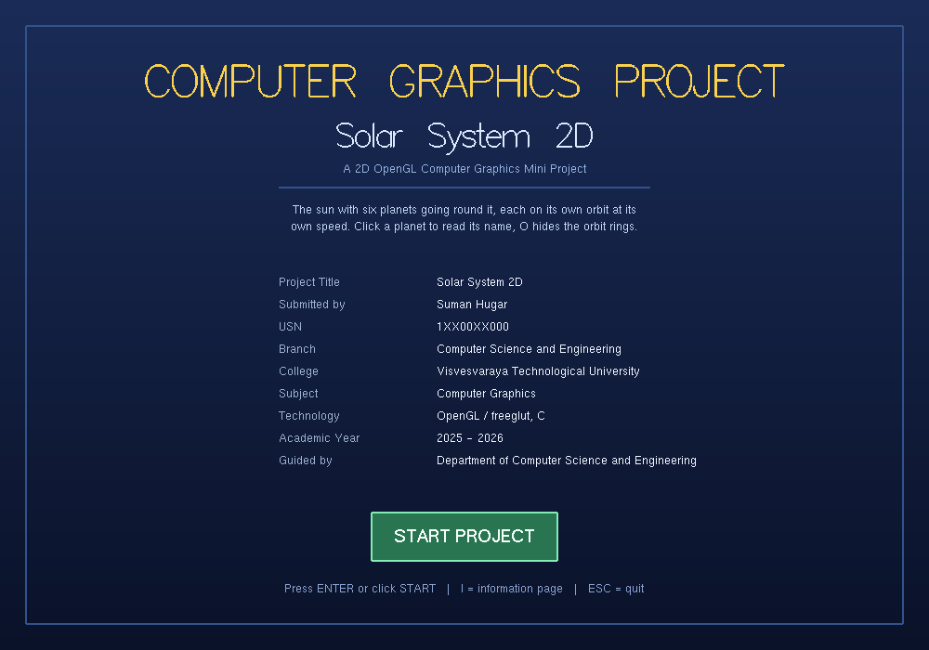
Figure 2 — Basic Solar System 2D, the title page
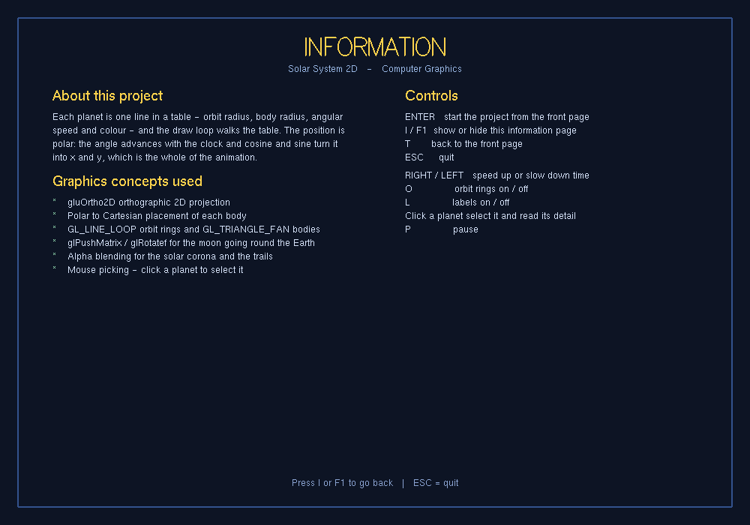
Figure 3 — Basic Solar System 2D, the project information page

10. Viva Questions and Answers
These are the questions an examiner is most likely to ask about the techniques this program uses.
Q1. What do glPushMatrix and glPopMatrix do?
They save and restore the current transformation matrix. Push takes a copy so the matrix can be modified freely for one object, and pop discards the modified copy and puts back what was there. Without them, every transformation would accumulate into everything drawn afterwards.
Q2. Why does the order of glTranslate and glRotate matter?
Because matrix multiplication is not commutative. Translating then rotating turns the object about its own new origin; rotating then translating swings it around the old origin on the end of a lever. Both are legal and they give completely different results.
Q3. How is hierarchical modelling demonstrated in this project?
Each moving part is drawn between a push and a pop inside its parent's transformation, so rotating the parent carries the child with it automatically.
Q4. What is alpha blending?
Combining a new fragment with the contents of the framebuffer according to an opacity value, rather than overwriting. The standard function weights the source by its alpha and the destination by one minus alpha.
Q5. Why must transparent objects be drawn after opaque ones?
Because the depth test would otherwise discard fragments behind a transparent surface that had already written its depth, and those fragments are exactly the ones that should have shown through it.
Q6. Why do overlapping translucent shapes look denser where they overlap?
Each layer blends over the result of the previous one, so the contributions compound. Two layers at fifty percent do not give fifty percent.
Q7. What is the difference between perspective and orthographic projection?
Perspective divides by depth, so objects shrink as they get further away and parallel lines converge; it matches how we see. Orthographic keeps size independent of distance and preserves parallelism, which suits 2D scenes, overlays and engineering views.
Q8. What do the near and far planes do, and why not just make the range huge?
They bound the region that gets projected, and the depth buffer's limited precision is distributed across that range. A very large far-to-near ratio leaves too little precision at distance, which produces z-fighting — surfaces flickering against each other.
Q9. What are the arguments to gluLookAt?
The eye position, the point being looked at, and an up vector. Together they define the view transformation that is applied to the whole scene.

11. Limitations and Future Work
- The scene is two-dimensional. Rebuilding it with a perspective projection and a depth buffer would be the natural extension.
- No texture mapping is used; surfaces are solid colours. Applying textures would add surface detail without adding geometry.
- The program uses the fixed-function pipeline, which is deprecated in modern OpenGL. A port to shaders and vertex buffer objects would be the route to a contemporary implementation.
- Geometry is submitted in immediate mode each frame. Display lists or vertex arrays would reduce the per-frame cost on larger scenes.

12. Conclusion
This project implements Basic Solar System 2D as a complete, self-contained OpenGL program in 639 lines of C. It demonstrates alpha blending, matrix stack (hierarchical modelling), orthographic projection, timer-driven animation, mouse input, and it does so without relying on any external asset, which keeps the whole of the behaviour visible in the source.
Working through it gives practical experience of the parts of the graphics pipeline that the syllabus treats separately — transformation, viewing, rasterisation and interaction — in a setting where a mistake in any one of them is immediately visible on screen. That immediate feedback is what makes graphics a good subject to learn by building.

